

# **School of Computer Science and Engineering**

# **CSE4015 - Human Computer Interaction**

**Personalized Culinary Companion: A Web Platform for Dynamic Recipe Recommendations, Ingredient-Based Filtering, and User-Generated Recipe Integration**

# Submitted by

# **Aleena 20BCE0200**

# Under the guidance of

# **Professor Swarnalatha P**

**Abstract**

The goal of this project is to develop a comprehensive recipe management system that enables users to efficiently explore, filter, and view detailed information about various dishes. The system is designed to provide a user-friendly interface for searching recipes based on ingredients, cuisines, diets, and other relevant filters. Additionally, users can contribute to the platform by submitting their own recipes, enhancing the diversity of available dishes. The project aims to create a seamless and enjoyable experience for both recipe seekers and contributors.

# **Introduction**

In today's fast-paced work environment, individuals are constantly engrossed in their professional responsibilities, and so, they aspire to swiftly cook their meals without dedicating much time to the decision-making process. The monotony of consuming the same dishes daily can lead to a sense of tedium, thus, there arises a need for a diverse array of accessible recipes. Yet, formulating such recipes presents a challenge of its own, such as modifying meals daily to cater to the diner's preferences while also prioritizing their nutritional needs. Moreover, oversight in stocking the kitchen with essential ingredients is another issue that can surface, which becomes particularly troublesome when individuals desire to prepare a quick meal.

In the realm of culinary exploration and meal preparation, the advent of digital technology has brought forth both challenges and opportunities. With the relentless pace of modern life, individuals seek convenient and efficient ways to access diverse recipes that cater to their culinary preferences, nutritional needs, and the ingredients readily available in their kitchens.

The existing landscape of culinary websites and platforms offers a multitude of recipes, but navigating through this vast sea of content can be a daunting and laborious task. Many existing platforms heavily rely on video content for recipe sharing. While videos provide visual guidance, they can be time-consuming and less efficient for those seeking quick access to ingredient lists and instructions. This has led to the need for a more accessible and text-based alternative, enabling users to quickly grasp information without the hassle of watching entire videos.

To address these challenges and enhance the user experience in culinary exploration, this project introduces a novel web application which serves as a centralized repository of a vast number of recipes. Its core functionality empowers users to effortlessly filter recipes based on the ingredients available at their disposal and their unique nutritional requirements. Additionally, the platform encourages user participation by enabling recipe contributions, fostering a vibrant community of culinary enthusiasts, and therefore promoting the tradition of recipe-sharing. With this innovative solution, we aim to streamline and elevate the culinary journey, offering users a more efficient, accessible, and comprehensive resource for discovering and sharing recipes, all in one centralized digital hub.

**Scope**

The Personalized Culinary Companion will cover the following key features and functionalities:

1. **Recipe Search and Filtering:**
   * Users can efficiently search for recipes based on ingredients, cuisines, diets, and other relevant filters.
   * Advanced filtering options, including ingredients, cuisine types, diet preferences, and sorting preferences.
2. **Recipe Display:**
   * Detailed information for each recipe, encompassing preparation time, servings, weight per serving, dish type, diet type, and cuisine.
   * In-depth nutritional information such as protein, fat, carbohydrates, glycemic index, glycemic load, and nutrition score.
3. **User Contribution:**
   * Users can actively contribute to the platform by submitting their own recipes.
   * Submitted recipes will undergo a review process before being added to the system to ensure quality and accuracy.
4. **User-Friendly Interface:** The system will have an intuitive and user-friendly interface for easy navigation and interaction.

**Objectives**

This HCI project endeavours to address several culinary challenges by creating a dynamic web application with the following objectives:

1. **Recipe Accessibility and Customization:** To provide users with a platform where they can effortlessly input their available ingredients and nutritional requirements, allowing the application to filter and suggest recipes that closely match their criteria.
2. **Effortless Recipe Discovery:** To simplify the process of finding diverse and tailored recipes, thereby minimizing the need to scour various websites for culinary inspiration.
3. **Community Engagement:** To foster an interactive community by enabling users to contribute their own recipes, thereby promoting the cherished tradition of sharing culinary wisdom.

**Requirement Specification**

**Hardware Requirements**

* The system should be accessible on standard personal computers and laptops.
* Minimum system requirements include a modern web browser and a stable internet connection.

**Software Requirements**

1. **Frontend:** Utilize HTML, CSS, and vanilla JavaScript for the user interface.
2. **Backend:** 
   1. Use Node.js for the server-side development.
   2. Implement Express.js framework.
   3. Use MongoDB database system for storing the recipes.
3. **Database:**
   1. Implement the NoSQL database to store recipes, and other relevant information.
   2. Ensure proper indexing and optimization for efficient data retrieval.
4. **Testing:**
   1. Conduct unit testing and integration testing for both frontend and backend components.
   2. Perform user acceptance testing to ensure the system meets user expectations.
5. **Scalability:** Design the system to be scalable to accommodate a growing database of recipes and user contributions.

**Methods Identified**

The development and implementation of the Personalized Culinary Companion involve a variety of methodologies and technologies to ensure a robust and user-friendly platform. The following methods have been identified for the successful execution of the project:

1. **Agile Development Methodology:** Adopting the Agile approach allows for iterative and incremental development, ensuring flexibility to accommodate changes and enhancements throughout the project lifecycle. This methodology is particularly beneficial for a dynamic and evolving system like this.
2. **User-Centered Design (UCD):** Utilizing the principles of User-Centered Design involves engaging potential users throughout the design and development phases. This approach ensures that the system is intuitive, user-friendly, and aligned with the expectations and needs of the target audience.
3. **Full-Stack Development:** Leveraging full-stack development enables the creation of a comprehensive system by addressing both frontend and backend requirements. Technologies such as Node.js, Express.js, and MongoDB on the backend, coupled with HTML, CSS, and JavaScript on the frontend, facilitate a seamless and integrated development process.
4. **Database Management:** Implementing a robust database management system, such as MongoDB, allows for efficient storage and retrieval of recipe data. The NoSQL nature of MongoDB provides flexibility in handling diverse data types and supports scalability as the system grows.
5. **Responsive Web Design (RWD):** Prioritizing Responsive Web Design ensures that the system is accessible and user-friendly across various devices and screen sizes. This method involves designing and developing the interface to adapt seamlessly to desktops, tablets, and mobile devices.
6. **Continuous Integration and Deployment (CI/CD):** Implementing CI/CD pipelines ensures automated testing, integration, and deployment processes. This method enhances the development workflow, accelerates release cycles, and maintains the stability and reliability of the system.

**Process Model**

The Personalized Culinary Companion system follows an iterative and incremental development process, aligning with the Agile methodology. The development lifecycle comprises the following key phases:

1. **Project Planning:**

* Define project scope, objectives, and requirements.
* Establish the development timeline and allocate responsibilities.
* Plan sprints, milestones, and release cycles.

1. **Requirements Gathering:**

* Engage stakeholders to gather detailed requirements.
* Identify user stories, features, and functionalities.
* Prioritize requirements based on business value.

1. **Design Phase:**

* Create wireframes and prototypes for the user interface.
* Define the system architecture, including frontend and backend components.
* Plan the database schema and relationships.

1. **Implementation:**

* Develop the frontend using HTML, CSS, and JavaScript.
* Implement backend logic using Node.js and Express.js.
* Integrate MongoDB for data storage and retrieval.

1. **Testing:**

* Conduct unit testing for individual components.
* Perform integration testing to ensure seamless communication.
* Execute system testing to validate end-to-end functionality.
* Implement automated testing for continuous integration.

1. **User Acceptance Testing (UAT):**

* Collaborate with end-users to validate system functionality.
* Gather feedback on usability, performance, and features.
* Iterate on design and functionality based on UAT results.

1. **Deployment:**

* Package the application for deployment.
* Implement CI/CD pipelines for automated deployment.
* Deploy the system to a production environment.

1. **Monitoring and Optimization:**

* Implement monitoring tools to track system performance.
* Gather analytics on user interactions and preferences.
* Optimize the system based on real-world usage.

1. **Maintenance and Updates:**

* Address bug fixes and issues promptly.
* Release updates and new features based on user feedback.
* Continuously refine and enhance the system.

# **System Architecture – Block Diagram** The system architecture of the Personalized Culinary Companion system can be represented through a block diagram, illustrating the key components and their interactions:

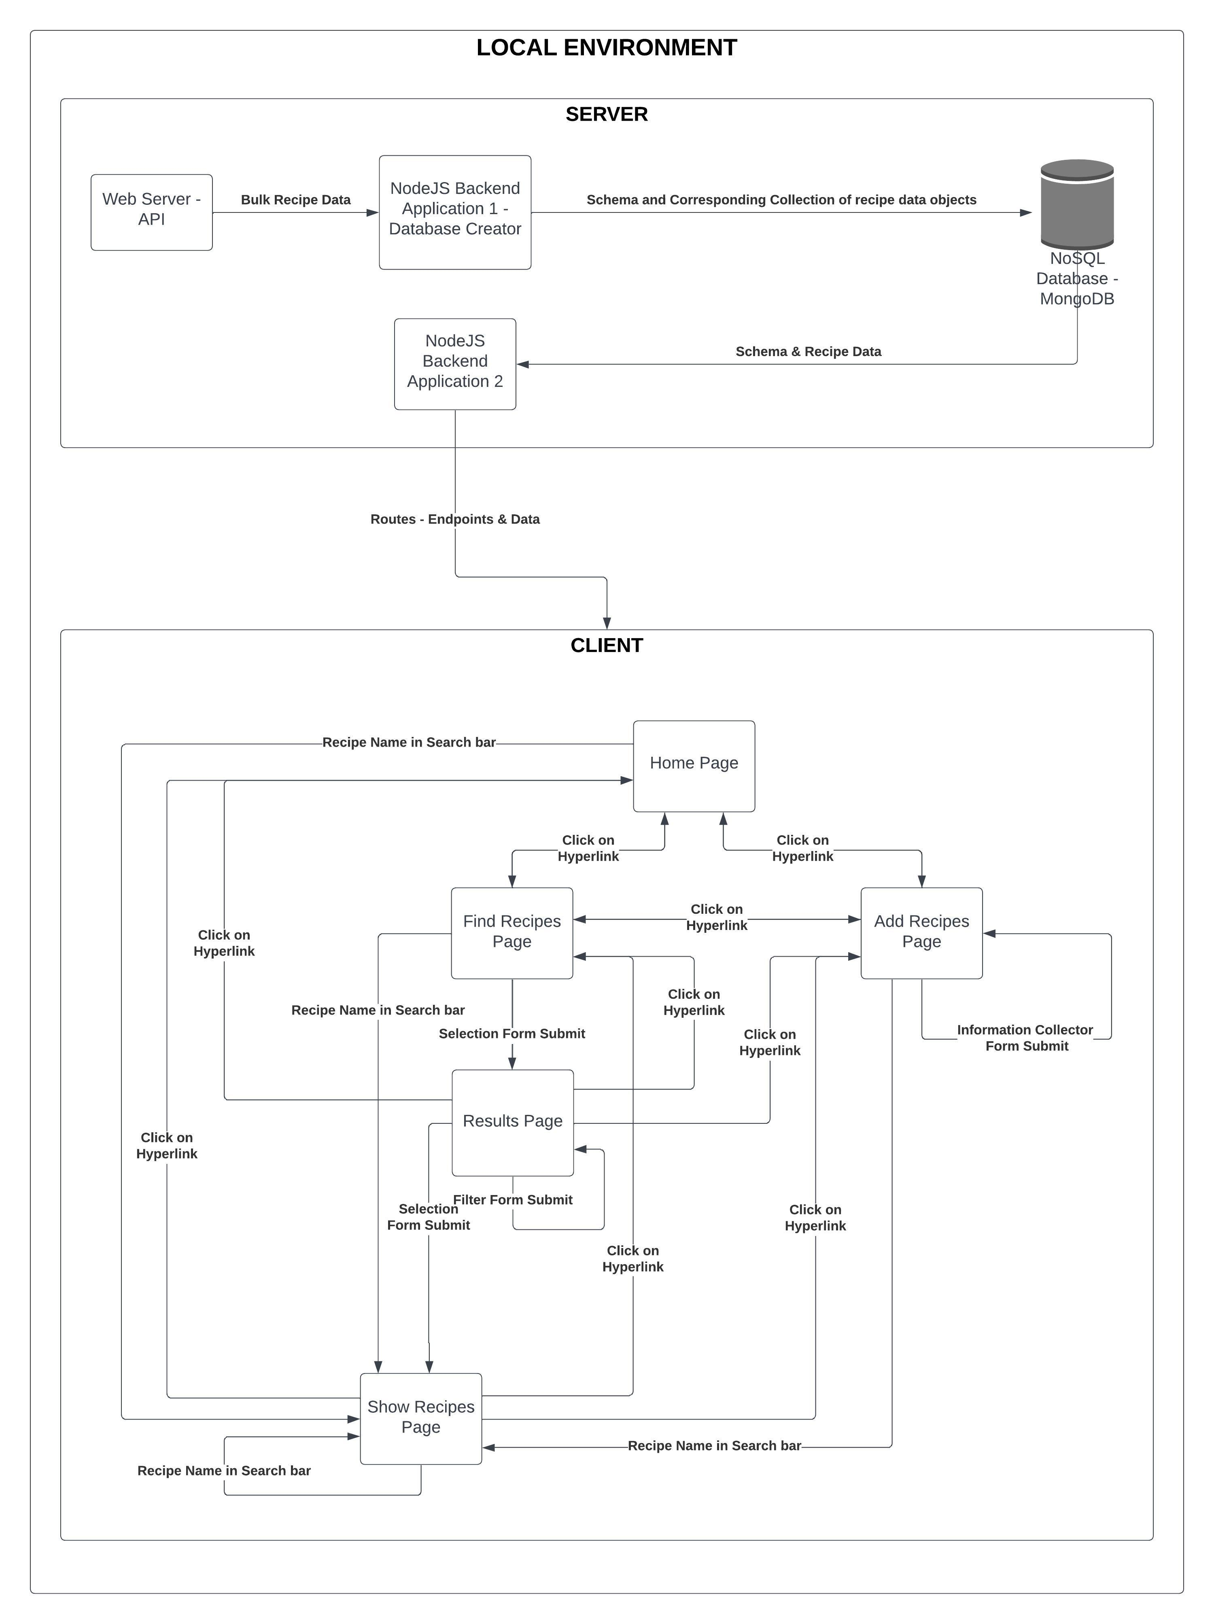

Figure 1: Block Diagram of the System showing the dataflow and interactions between components

**Design Specifications**

**HTA**

**Interaction Design**

**Stakeholders Identification**

**Storyboarding**

**Use Case Modelling**

**Personas**

**State Transition Network**

HTA, INTERACTION DESIGN( 4 STEPS) STAKEHOLDERS IDENTIFICATION, STORYBOARDING,USE CASE MODELLING,PERSONAS,STATE TRANSITION NETWORK

APPLY OF SCHENIDEMAN'S/NORMAN'S/NIELSEN'S, HERISTIC EVALUATION,KLM, GOMS -GENERATE A TABLE AND GRAPH

COMMUNICATION AND COLLABORATION, GROUPWARE

VALIDATION-USABILITY TESTING, INTERFACE TESTING,USER ACCEPTANCE TESTING : USING ANY OPEN SOURCE TOOL

RESULTS AND DISCUSSION-GRAPH GENERATION

CONCLUSION: CONCLUDING WITH GIVING DETAILS OF IMPROVEMENT IN PERFORMANCE AND APPLICABILITY OF THE SYSTEM IN REAL TIME ENVIRONMENT